GIS-Based Drainage Density Mapping Using DEM

1. Project Overview
This document provides a step-by-step workflow for preparing a drainage-density map in ArcGIS 10.8. The analysis uses a Digital Elevation Model (DEM) to derive the drainage network and then calculates spatial drainage density using the Line Density tool. The final drainage-density raster is classified into five classes: Very Low, Low, Moderate, High, and Very High.

2. Objectives
- To derive the drainage network from a DEM using hydrological analysis.
- To convert the extracted stream network into suitable drainage-line features.
- To project the drainage network into a metric projected coordinate system.
- To calculate spatial drainage density using Line Density.
- To classify drainage density into five classes.
- To prepare a clear final drainage-density map for reporting.

3. Software and Data Required
Requirement | Example | Purpose
Software | ArcGIS 10.8 / ArcMap | GIS processing and map preparation
Extension | Spatial Analyst | Hydrology, raster and Line Density tools
Input data | DEM | Derive flow and drainage network
Boundary | Study-area/watershed polygon | Clip and interpret results
Coordinate system | WGS 1984 UTM Zone 44N | Metric length and area analysis

4. Complete Workflow
1. Add the DEM to ArcMap.
2. Set the DEM processing environment.
3. Fill DEM sinks.
4. Create Flow Direction.
5. Create Flow Accumulation.
6. Define the stream network using a flow-accumulation threshold.
7. Convert the stream raster to polyline features.
8. Project the stream polyline layer to WGS 1984 UTM Zone 44N.
9. Run Line Density using the projected stream lines.
10. Check the output coordinate system and statistics.
11. Reclassify drainage density into five classes.
12. Rename the classes Very Low, Low, Moderate, High and Very High.
13. Prepare the final map layout.
14. Export the final map.

5. Step 1 – Add the DEM
Open ArcMap 10.8 and create/open your project MXD.
- Click Add Data.
- Browse to the DEM file.
- Select the DEM and click Add.
- Confirm that the DEM covers the complete study area.
Recommended check: Right-click the DEM → Properties → Source and record the coordinate system, cell size and units.

6. Step 2 – Fill Sinks
Go to:
ArcToolbox → Spatial Analyst Tools → Hydrology → Fill
- Input surface raster: DEM.
- Output surface raster: Fill_DEM.
- Click OK.
Purpose: remove small depressions that can interrupt the modeled drainage flow.

7. Step 3 – Flow Direction
Go to:
Spatial Analyst Tools → Hydrology → Flow Direction
- Input surface raster: Fill_DEM.
- Output flow direction raster: FlowDir_Fill.
- Click OK.

8. Step 4 – Flow Accumulation
Go to:
Spatial Analyst Tools → Hydrology → Flow Accumulation
- Input flow direction raster: FlowDir_Fill.
- Output accumulation raster: FlowAcc_Fill.
- Weight raster: leave empty unless your methodology requires one.
- Click OK.

9. Step 5 – Define the Stream Network
A flow-accumulation threshold is used to identify cells that represent drainage channels. The threshold must be selected and documented according to the DEM resolution and study objective.
Example expression in Raster Calculator:
Con ("FlowAcc_Fill" >= THRESHOLD, 1)
Replace THRESHOLD with the value justified for your study. Do not select a value only to make the map look better.

10. Step 6 – Convert Stream Raster to Polyline
Use:
Spatial Analyst Tools → Hydrology → Stream to Feature
- Input stream raster: your defined stream raster.
- Input flow direction raster: FlowDir_Fill.
- Output polyline: for example, StreamT_Stream07.
- Click OK.
The result should be a polyline feature class. This is the type of data required by the Line Density tool.

11. Step 7 – Project the Stream Lines
This step is important because your earlier layer was in GCS_WGS_1984, which uses angular units (degrees). For drainage-density calculations, use a projected coordinate system with metre units.
Use:
Data Management Tools → Projections and Transformations → Feature → Project
- Input Features: StreamT_Stream07 (or your actual stream polyline layer).
- Output Feature Class: StreamT_Stream07_Project.
- Output Coordinate System: WGS 1984 UTM Zone 44N.
- Click OK.
Verification:
- Right-click the projected stream layer → Properties → Source.
- Spatial Reference should be WGS_1984_UTM_Zone_44N.
- Linear Unit should be Meter.
- The layer should be a polyline feature class.

12. Step 8 – Calculate Drainage Density Using Line Density
Open:
Spatial Analyst Tools → Density → Line Density
Line Density parameter | Recommended project setting
Input polyline features | Projected stream polyline
Population field | NONE, unless a justified weighting field is required
Cell size | Use the DEM/data resolution; 30 m if the source DEM is 30 m
Search radius | Use a value justified by the study; document it
Area units | SQUARE_KILOMETERS when reporting km/km²
Output | Drainage_Density
Important: the search radius is not a universal fixed value. It affects the spatial density surface. Record the value used in the report and keep it consistent across comparisons.

13. Step 9 – Verify the Drainage-Density Raster
- Right-click Drainage_Density → Properties → Source.
- Check Spatial Reference = WGS 1984 UTM Zone 44N.
- Check Linear Unit = Meter.
- Record cell size.
- Record minimum, maximum and mean raster statistics.
- Confirm the Line Density Area Units used during calculation.
Only after confirming the Line Density Area Units should the numerical output be labelled with a unit such as km/km².

14. Step 10 – Reclassify Drainage Density into Five Classes
Use:
Spatial Analyst Tools → Reclass → Reclassify
- Input raster: Drainage_Density.
- Reclass field: VALUE.
- Choose a classification method appropriate to your study.
- Create five classes.
- Save the output as Drainage_Density_Final.

15. Step 11 – Name the Five Classes
Value | Class name | Meaning
1 | Very Low | Lowest drainage-density class
2 | Low | Low drainage-density class
3 | Moderate | Intermediate drainage-density class
4 | High | High drainage-density class
5 | Very High | Highest drainage-density class
Do not copy numerical class limits from an earlier raster if the Line Density calculation has been rerun. Use the actual statistics of the final raster.

16. Step 12 – Prepare the Final Map Layout
- Switch to View → Layout View.
- Resize the map frame so the study area is clearly visible.
- Add a clear title: GIS-Based Drainage Density Mapping Using DEM and ArcGIS 10.8.
- Insert a legend showing Very Low, Low, Moderate, High and Very High.
- Add a north arrow.
- Add a scale bar.
- Add coordinate/grid information if required.
- Add data source, author and projection information where appropriate.
- Remove unnecessary intermediate layers from the final map.

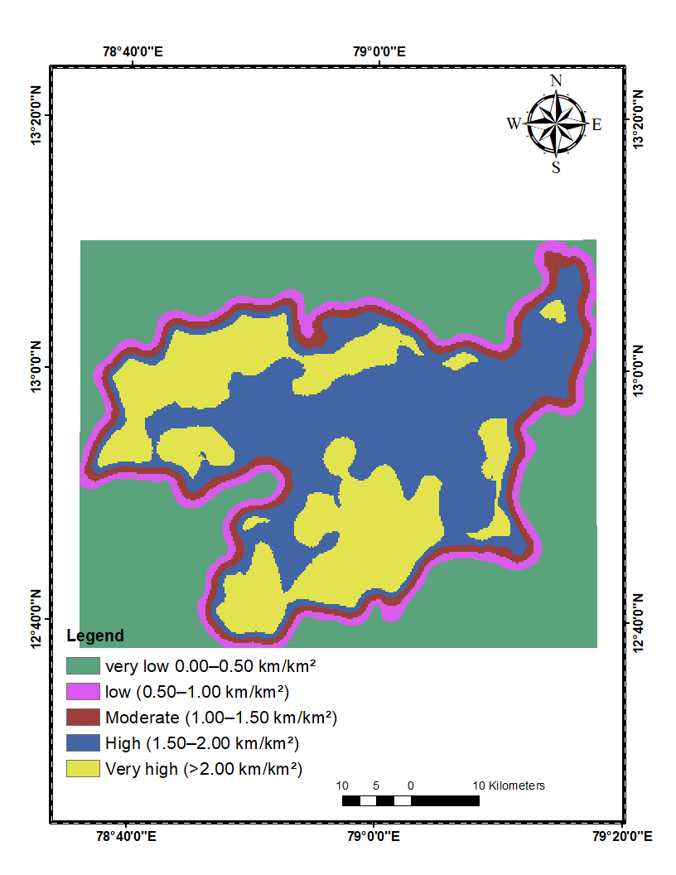
Figure 1. Current ArcMap drainage-density map output with five classified classes.

17. Optional Step – Automate Line Density with Python
Python can be used inside ArcMap 10.8 to automate the Line Density calculation. The input path must be the actual projected stream feature class in your geodatabase. Do not use a guessed layer name.
import arcpy
from arcpy.sa import *
arcpy.CheckOutExtension("Spatial")
streams = r"C:\path\to\Default.gdb\Projected_Stream"
output = r"C:\path\to\Default.gdb\Drainage_Density"
dd = LineDensity(
streams,
"NONE",
30,
500,
"SQUARE_KILOMETERS"
)
dd.save(output)
print("Drainage density calculation completed.")
The example uses 30 m cell size and 500 m search radius only as placeholders. The cell size should match the project data, and the search radius should be justified by the study methodology.

18. Drainage Density Formula
Dd = L / A
Where:
Dd = drainage density (commonly km/km²)
L = total length of drainage channels (km)
A = basin or watershed area (km²)

19. Interpretation of the Final Map
Very Low and Low drainage-density zones indicate relatively sparse drainage development. Moderate zones represent intermediate drainage development. High and Very High zones indicate relatively greater concentration of drainage lines within the analysis neighbourhood. The map should be interpreted together with slope, geology, soil, rainfall and land-use/land-cover information.

20. Common Problems and Solutions
Problem | Likely cause | Solution
Input stream does not exist | Wrong file path or layer name | Use the actual data source path shown in Layer Properties → Source.
Line Density rejects input | Input is raster rather than polyline | Use Stream to Feature to create a polyline stream layer.
Coordinate system is GCS_WGS_1984 | Layer is geographic | Project the stream polyline to WGS 1984 UTM Zone 44N.
Values change after rerunning | Different cell size/search radius/stream threshold | Document and keep parameters consistent.
Legend shows only 1–5 | Class codes not renamed | Edit Symbology labels to Very Low–Very High.

21. Final Submission Checklist
- DEM processed and drainage network extracted.
- Stream network converted to polyline.
- Stream polyline projected to WGS 1984 UTM Zone 44N.
- Linear unit verified as metre.
- Line Density calculated using the projected stream network.
- Area Units verified.
- Final raster statistics recorded.
- Five classes created and named.
- Final map contains title, legend, north arrow and scale bar.
- Final map exported at suitable resolution.
- Methodology and parameter values documented in the report.

22. Conclusion
The GIS workflow described in this document provides a reproducible method for producing a drainage-density map in ArcGIS 10.8. The key quality-control requirement is to calculate Line Density from a projected stream polyline layer and to document the cell size, search radius, area units and classification method. Once these parameters are verified, the five-class drainage-density map can be used as the final project output.
Units: km/km²

23. References
- Horton, R. E. (1945). Erosional development of streams and their drainage basins: Hydrophysical approach to quantitative morphology. Geological Society of America Bulletin, 56, 275–370.
- Strahler, A. N. (1957). Quantitative analysis of watershed geomorphology. Transactions, American Geophysical Union, 38(6), 913–920.
- Esri. ArcGIS 10.8 Spatial Analyst documentation: Hydrology and Density tools. Esri, Redlands, California.

